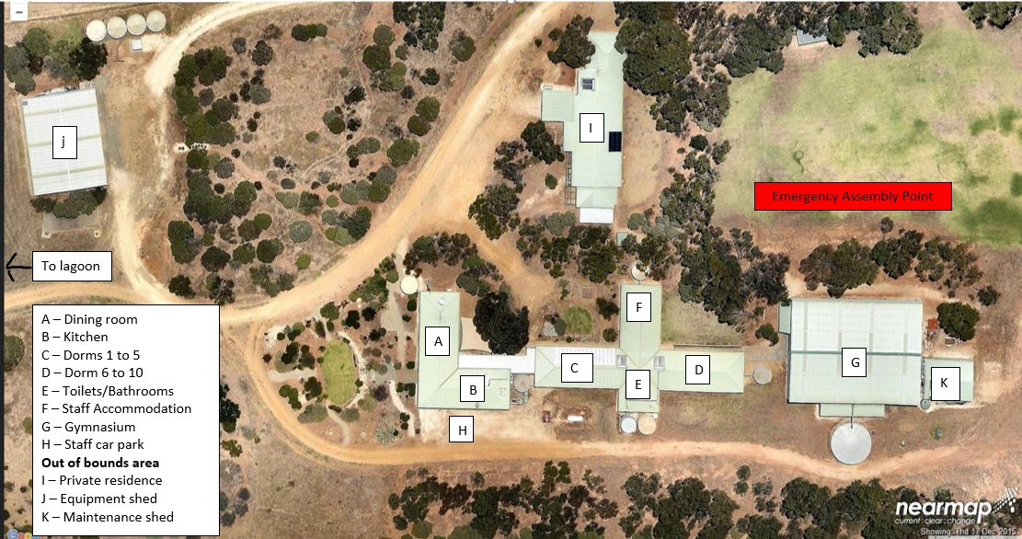

|  |  |  |  |
| --- | --- | --- | --- |
| **Section C** | | | |
| Dorm 1 (4 Bunks) | | Dorm 2 (4 Bunks) | |
| 1 |  | 1 |  |
| 2 |  | 2 |  |
| 3 |  | 3 |  |
| 4 |  | 4 |  |
| 5 |  | 5 |  |
| 6 |  | 6 |  |
| 7 |  | 7 |  |
| 8 |  | 8 |  |
|  |  |  |  |
| Dorm 3 (4 Bunks) | | Dorm 4 (4 Bunks) | |
| 1 |  | 1 |  |
| 2 |  | 2 |  |
| 3 |  | 3 |  |
| 4 |  | 4 |  |
| 5 |  | 5 |  |
| 6 |  | 6 |  |
| 7 |  | 7 |  |
| 8 |  | 8 |  |
|  |  |  |  |
| Dorm 5 (4 Bunks) | |  |  |
| 1 |  |  |  |
| 2 |  |  |  |
| 3 |  |  |  |
| 4 |  |  |  |
| 5 |  |  |  |
| 6 |  |  |  |
| 7 |  |  |  |
| 8 |  |  |  |

|  |  |  |  |
| --- | --- | --- | --- |
| **Section D** | | | |
| Dorm 6 (4 Bunks) | | Dorm 7 (4 Bunks) | |
| 1 |  | 1 |  |
| 2 |  | 2 |  |
| 3 |  | 3 |  |
| 4 |  | 4 |  |
| 5 |  | 5 |  |
| 6 |  | 6 |  |
| 7 |  | 7 |  |
| 8 |  | 8 |  |
|  |  |  |  |
| Dorm 8 (4 Bunks) | | Dorm 9 (4 Bunks) | |
| 1 |  | 1 |  |
| 2 |  | 2 |  |
| 3 |  | 3 |  |
| 4 |  | 4 |  |
| 5 |  | 5 |  |
| 6 |  | 6 |  |
| 7 |  | 7 |  |
| 8 |  | 8 |  |
|  |  |  |  |
| Dorm 10 (4 Bunks) | |  |  |
| 1 |  |  |  |
| 2 |  |  |  |
| 3 |  |  |  |
| 4 |  |  |  |
| 5 |  |  |  |
| 6 |  |  |  |
| 7 |  |  |  |
| 8 |  |  |  |

|  |  |  |  |
| --- | --- | --- | --- |
| **Section F** | | | |
| Staff Accommodation 1 (1 Bunk, 1 Single) | | Staff Accommodation 2 (1 Bunk, 1 Single) | |
| 1 |  | 1 |  |
| 2 |  | 2 |  |
| 3 |  | 3 |  |
|  |  |  |  |
| Staff Accommodation 3 (1 Bunk, 1 Single) | | Staff Accommodation 4 (1 Bunk, 1 Single) | |
| 1 |  | 1 |  |
| 2 |  | 2 |  |
| 3 |  | 3 |  |
|  |  |  |  |
| Staff Accommodation 5 (1 Bunk, 1 Single) | |  |  |
| 1 |  |  |  |
| 2 |  |  |  |
| 3 |  |  |  |